Subject "Pharmaceutical chemistry 2"
Lecture 10. Diuretic medicinal substances. Medicinal substances used in violation of water-electrolyte (ion exchange) and acid-base balance.

This group of drugs includes drugs of various chemical structures that inhibit the reabsorption of water and salts in the tubules of the kidneys, and increase their excretion in the urine.
Drugs that increase the rate of urine formation are used for cardiac edema (chronic heart failure, CHF), renal and hepatic edema. In all these forms of pathology (especially in CHF), the patient has a positive sodium balance (that is, the amount of sodium taken with food exceeds its excretion). The excretion of sodium from the body is accompanied by a decrease in edema. Therefore, those diuretics that increase, first of all, natriuresis are of the greatest importance.
Three processes play a major role in the formation of urine:
1) filtration;
2) reabsorption;
3) tubular secretion.
These processes are due to the peculiarities of the morpho-functional organization of the kidney. It is known that the medulla of the kidney consists of nephrons, which have in their structure a vascular glomerulus located in the Shumlyansky-Bowman capsule, where blood plasma is filtered and primary urine is formed, devoid of high-molecular proteins and other compounds. Normal daily glomerular filtrate is about 150 liters and contains approximately 1.2 kg of sodium.
Filtration is a passive process; is provided by the pumping function of the heart, the oncotic pressure of the undifferentiated part of the plasma, as well as the number of functioning glomeruli.
Primary urine enters the second section - the tubules, which are divided into the proximal, distal sections and the loop of Henley. In the tubules, the process of reabsorption (that is, reverse absorption) into the blood of water, sodium, potassium, chlorine, bicarbonate, etc.
Also in this area amino acids, vitamins, glucose, proteins, microelements are completely reabsorbed. This process takes place with the participation of a number of enzymes (carbonic anhydrase, etc.). Secretory processes are also observed in the tubules, as a result of which some metabolites, xenobiotics (for example, penicillin, etc.) are released. As a result of reabsorption, secondary urine is formed, which is excreted from the body of a healthy person in the amount of 1.5 liters and contains 0.005 kg of sodium per day.
Reabsorption of sodium occurs mainly in the distal tubules under the action of the hormone of the adrenal cortex - aldosterone. In the case of an increase in the level of aldosterone, sodium and water are retained in the body (which happens with heart failure, liver diseases, etc.). The release of aldosterone is stimulated by angiotensin-II, and therefore one of the functions of the latter is the mediated retention of sodium in the body, and hence water.
In the distal tubules, the processes of water reabsorption are also influenced by antidiuretic hormone (ADH), or vasopressin (hormone of the posterior pituitary gland). ADH, by facilitating the reabsorption of water, reduces the volume of urine, increasing its osmolarity.
Atriopeptides or natriuretic factors have also been isolated, which are normally produced in the auricles when they are too much stretched by blood and regulate water-sodium homeostasis.
All the main drugs of the diuretic group act on reabsorption processes, inhibit them, although tubular water reabsorption is reduced by only 1%.
For use in clinical practice, classifications that subdivide diuretics according to the strength of action, the speed of onset of the effect and the duration of action are important.
Diuretics (from the Greek. διούρησις - urination; diuretics) - means of various chemical structures that inhibit the reabsorption of water and salts in the tubules of the kidneys and increase their excretion in the urine; increasing the rate of urine formation and thus reducing the fluid content in the tissues and serous cavities. Diuretics that decrease sodium reabsorption and increase natriuresis are called saluretics.
Diuretics are used mainly for arterial hypertension and for diseases of the cardiovascular system, liver and kidneys, accompanied by edema - but not for all diseases with edema, and only as prescribed by a doctor. The doctor prescribes them in the absence of contraindications for pathologies (especially in chronic heart failure) in cases where the patient has a positive sodium balance (that is, the amount of sodium taken with food exceeds its excretion).
The removal of sodium from the body is accompanied by a decrease in edema. Therefore, those diuretics that increase, first of all, natriuresis and chloruresis (saluretics - from the Latin name of table salt) are of the greatest importance.
Natriuretics are diuretics that cause a particularly strong release of sodium ions. By action, diuretics are divided into renal (that is, acting directly on the kidneys), which give the greatest effect, and extrarenal, that is, they have a diuretic effect indirectly through other body systems. Renal diuretics also have an effect on other body systems.
There are 3 main classifications of diuretics:
- by chemical structure;
- by localization of action in the nephron;
- according to the mechanism of action.
Classification according to the localization of action in the nephron.
1. Means that affect glomerular filtration:
xanthine derivatives:
- eufillin;
- theophylline;
- theobromine.
2. Means acting on the proximal tubule of the nephron:
osmotic diuretics:
- mannitol (mannitol);
- urea.
Carbonic anhydrase inhibitors:
- diacarb.
3. Means acting in the loop of Henle ("loop" diuretics):
- furosemide (lasix);
- ethacrynic acid;
- dichlothiazide (hypothiazide);
- mercury diuretics (merkusal, noburit, promeran).
4. Aldosterone antagonists:
- spironolactone (veroshpiron).
5. Blockers of transport of sodium and potassium ions through the apical membrane of the epithelium of the renal tubules:
- triamterene;
- amiloride.
Chemical classification of diuretics:
1. A subgroup of thiazides (containing a sulfanilamide group) - dichlorothiazide, cyclomethiazide;
2. Non-thiazide or "loop" diuretics - furosemide, clopamid, oxodoline, bufenox, diacarb;
The first and second subgroups (thiazides and nethiazides) are combined under the name diuretics containing sulfanilamide groups.
3. Derivatives of dichlorophenoxyacetic acid - ethacrynic acid;
4. Xanthines - eufillin, temisal;
5. Derivatives of pteridine or potassium protectors - triamterene;
6. Derivatives of pyrazinoylguanidine - amiloride;
II. Aldosterone antagonists - spironolactone.
III. Diuretics with osmotic activity - mannitol, urea.
PHARMACOLOGICAL CLASSIFICATION OF DIURETICS
I. Powerful, or strongly acting ("ceiling") diuretics
- furosemide, ethacrynic acid;
II. Medium-strength diuretics, benzothiadiazine derivatives (thiazide diuretics)
- dichlothiazide, polythiazide;
III. Potassium-sparing diuretics
1) aldosterone antagonists:
- spironolactone (veroshpiron);
2) with an unknown mechanism of action:
- triamterene, amiloride.
In terms of strength, these are weak diuretics.
IV. Carbonic anhydrase inhibitors:
- diacarb.
This drug, as a diuretic, also belongs to weak diuretics.
All four of the above groups of agents primarily remove salts, primarily sodium and potassium, as well as anions of chlorine, bicarbonates, phosphates. That is why the drugs of these four groups are called saluretics.
V Osmotic diuretics
- mannitol, urea, concentrated glucose solutions, glycerin.
These diuretics are placed in a separate group, since they primarily remove water from the body.
The use of diuretics is designed to change the balance of sodium in the body, making it negative. Only in this case, increased sodium excretion will be accompanied by an increase in the excretion of water from the body and a decrease in edema.
Renal diuretics
The mechanism of action of renal diuretics is explained by the ability to block kidney enzymes that provide electrolyte transport, and inhibition of reabsorption in the terminal tubules, which leads to a significant increase in the excretion of sodium, chlorine, and potassium ions. Renal include:
• mercury diuretics — merkusal, promeran, novurite;
• carbonic anhydrase inhibitors - diacarb, dichlorphenamide (diranide), which are derivatives of sulfonamide, which increase the excretion of bicarbonate from the body (the alkaline reserve of the blood decreases; acidosis may develop);
• derivatives of benzothiadiazine, sulfamoylanthranilic and dichlorophenoxyacetic acids - dichlothiazide (hypothiazid), furosemide (lasix), ethacrynic acid (uregit) - the strongest diuretics that dramatically increase the excretion of sodium, which also have a hypotensive effect;
• derivatives of pyrimidine and pteridine - allacyl and triamterene (pterofen), which inhibit tubular reabsorption of sodium and chloride ions and do not affect the release of potassium;
• aldosterone antagonists - spironolactone (aldactone, veroshpiron), which increase the excretion of sodium and reduce the excretion of potassium and urea.
Extrarenal diuretics
Extrarenal diuretics, depending on the mechanism of action, are divided into
• osmotic - potassium acetate, mannitol, urea, which are excreted by the kidneys and carry water with them, excrete sodium and chlorine in proportion to the increase in urine volume and are used to reduce intracranial pressure and reduce cerebral edema;
• acid-forming - ammonium chloride, calcium chloride and others, the action of which is associated with the transformation of cations (ammonium ion in the liver turns into urea, calcium ion is deposited in the intestine in the form of phosphate or carbonate, chloride ions in excess end up in the blood plasma and are excreted by the kidneys along with sodium)
As diuretics, extracts and infusions from plants are sometimes used: bearberry leaf (infusion, decoction), horsetail herb (decoction, liquid extract), orthosiphon leaf (infusion).
For use in clinical practice, classifications that subdivide diuretics according to the strength of action, the speed of onset of the effect and the duration of action are important.
The use of diuretics is designed to change the balance of sodium in the body, making it negative. Only in this case, increased sodium excretion will be accompanied by an increase in the excretion of water from the body and a decrease in edema.
I. Powerful or potent (“ceiling”) diuretics
Torasemid - Torasemidum (solution 5 mg / ml in amp. 4 ml in tab. 5-10 mg :)) - loop diuretic.

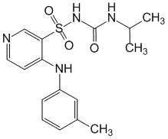

The maximum effect during the first two hours, the effect lasts up to 18 hours. Normalizes electrolyte imbalance. Torasemide has a long half-life, reduces the synthesis of thromboxane, thereby ensuring the prevention of vasospasm; does not affect the excretion of K, Mg, Ca. At a dose of 2.5 mg-5 mg, it is used as an antihypertensive drug.
Trigrim or Diuver (torasemide) is available in 2.5 mg, 5 mg, 10 mg or 20 mg tablets. The main mechanism of action of the drug is due to the reversible binding of torasemide to the sodium/chlorine/potassium ion transporter located in the apical membrane of the thick segment of the ascending loop of Henle, resulting in a decrease or complete inhibition of sodium ion reabsorption and a decrease in the osmotic pressure of the intracellular fluid and water reabsorption. Blocks myocardial aldosterone receptors, reduces fibrosis and improves diastolic myocardial function.
Torasemide, to a lesser extent than furosemide, causes hypokalemia, while it is more active, and its effect is longer. The use of torasemide is the most reasonable choice for long-term therapy.
Indications for the use of the drug:
1. Edema syndrome of various origins, including chronic heart failure, diseases of the liver, lungs and kidneys.
2. Arterial hypertension.

After oral administration, torasemide is rapidly and almost completely absorbed from the gastrointestinal tract. Bioavailability is 80-90% with slight individual variations. The diuretic effect of the drug lasts up to 18 hours, which facilitates the tolerability of therapy due to the absence of very frequent urination in the first hours after taking the drug orally, which limits the activity of patients.
Furosemide (Furosemidum; in tab. 0.04; 1% solution in amp. 2 ml)
C
H
2
N
H
l
C
S
2
O
N
2
H
C
O
O
H
O
It is considered a loop diuretic, since the diuretic effect is associated with inhibition of the reabsorption of sodium and chloride ions throughout the loop of Henle, especially in its ascending section. Recently, it has been used less and less due to a number of side effects - rebound syndrome, hypokalemia, alkalosis, osteoporosis.
Receipt:

C
H
3
[

O

]
C
O
O
H
C
l
2
C
O
O
H
l
C
C
l
H
O
S
O
2
C
l
C
O
O
H
l
C
C
l
S
2
O
l
C
N
H
3
C
O
O
H
l
C
C
l
S
2
O
N
2
H

2
H
C
N
H
2
O
F
u
r
o
s
e
m
i
d
f
u
r
f
u
r
i
lamin

;130⁰
Ethacrynic acid (uregitis; Acidum etacrinicum; uregitis; in tab. 0.05; 0.1)

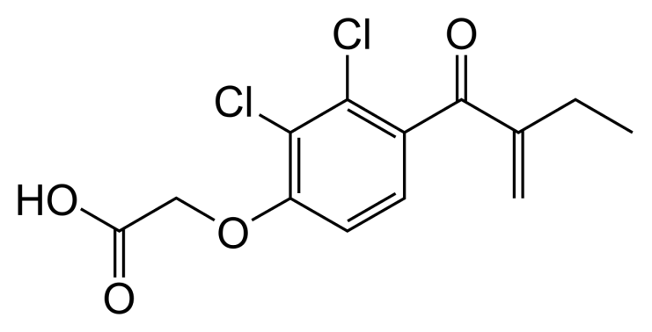
The drugs of this group inhibit sodium reabsorption by 10-20%, therefore they are powerful, short-acting diuretics. The pharmacological effect of both drugs is almost the same. The mechanism of action of furosemide is associated with the fact that it significantly increases renal blood flow (by increasing the synthesis of prostaglandins in the kidneys). Furosemide moderately (twice) increases the excretion of potassium and bicarbonate ion in the urine, to a greater extent - calcium and magnesium.
In addition to the diuretic effect, furosemide has the following actions, due to both a direct effect on all smooth muscles of the vascular wall, and a decrease in their sodium content, which, as a result, reduces the sensitivity of myocytes to catecholamines:
1. Direct pacemaker;
2. Antiarrhythmic;
3. Vasodilator;
4. Contrinsular.
When taken orally, the effect occurs within an hour, and the duration of action is 4-8 hours. With intravenous administration, the diuretic effect occurs after 3-5 minutes (in / m after 10-15 minutes), reaching a maximum after 30 minutes. In general, the effect lasts about 1.5-3 hours.
Side effects.
One of the most common adverse reactions is hypokalemia, which is accompanied by weakness of all muscles, anorexia, constipation and heart rhythm disturbances. This is also facilitated by the development of hypochloremic alkalosis, although this effect is not of particular importance, since the effect of these drugs does not depend on the reaction of the environment.
Basic principles of combating hypokalemia:
- intermittent administration of diuretics that cause loss of potassium;
- combining them with potassium-sparing diuretics;
- restriction of sodium in food;
- enrichment through a potassium-rich diet (raisins, dried apricots, baked potatoes, bananas);
- the appointment of potassium preparations (asparkam, panangin).
The drugs of this group also delay the secretion of uric acid, thereby causing the phenomena of hyperuricemia. This is especially important to consider in patients with gout.
In addition to hyperuricemia, drugs can cause hyperglycemia and exacerbation of diabetes. This effect is most likely in patients with latent and manifest types of diabetes.
Contributing to an increase in the concentration of atrium in the endolymph of the inner ear, these drugs cause an ototoxic effect (hearing damage). At the same time, if the use of furosemide causes reversible changes, then the use of uregit, as a rule, is accompanied by irreversible hearing impairment.
It should also be said about the impossibility of combining furosemide and ethacrynic acid with nephrotoxic and ototoxic antibiotics (ceporin, cephaloridine - first-generation cephalosporins), aminoglycoside antibiotics (streptomycin, kanamycin, etc.), which also have damaging side effects on the hearing organ.
When using drugs inside, minor, mild dyspeptic disorders are noted.
When taken, skin rashes, a decrease in the number of red blood cells, white blood cells, damage to the liver, pancreas are possible. In the experiment, drugs sometimes have a teratogenic effect.
Indications for use:
- in tablets:
1. With chronic edema caused by chronic
heart failure, liver cirrhosis, chronic nephritis;
2. As drugs of choice for heart failure with severe hemodynamic disorders;
3. In the complex therapy of patients with hypertension.
- in solution (in/in):
1. In acute edema of the brain and lungs (dehydration therapy, removal of water from tissues);
2. If necessary, forced diuresis (for acute drug poisoning and poisoning with other chemicals excreted mainly in the urine);
3. Hypercalcemia of various origins;
4. With a hypertensive crisis;
5. In acute heart failure.
The dose of furosemide, however, like any other diuretic, is considered to be correctly selected when for a given patient diuresis during the period of active therapy increases to 1.5-2 liters / day.
Ethacrynic acid has the same indications for use as furosemide, with the exception of hypertension, as it is not suitable for long-term use.
When taken orally, the effect occurs within an hour, and the duration of action is 4-8 hours. With intravenous administration, the diuretic effect occurs after 3-5 minutes (in / m after 10-15 minutes), reaching a maximum after 30 minutes. In general, the effect lasts about 1.5-3 hours.
Side effects:
One of the most common adverse events is hypokalemia, accompanied by weakness of all muscles, anorexia, constipation and heart rhythm disturbances. This also affects the development of hypochloremic alkalosis, although this effect is not of particular importance, since the effect of the drugs does not depend on the reaction of the environment.
Bumetanide, pyretanide are also referred to the drug of powerful, but energetic action.

Bumetanide

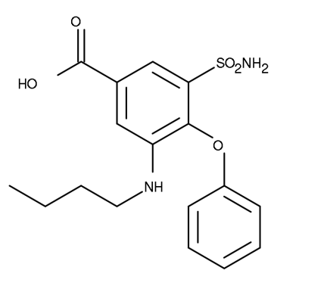
Bumetanide or Bumex, Bufenox - a medicine used in the treatment of kidney failure, hypertension, is a loop diuretic. Produced by Hoffmann-La Roche. It is released from pharmacies without a prescription. Bumetanide is being tested as a cure for autism and epilepsy. Included in the list of drugs prohibited in sports. Compared to furosemide, it has a higher bioavailability.

pyretanide

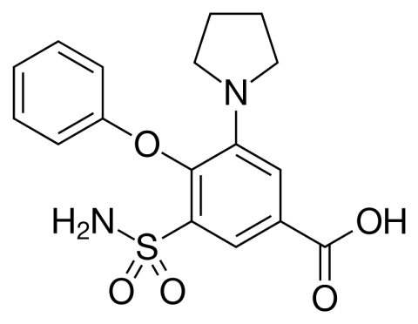
Pyretanide is a loop diuretic compound prepared using a then novel method for introducing cyclic amine residues into an aromatic ring in the presence of other aromatically linked functional groups. Studies of pyretanide in rats and dogs compared with other high-ceiling diuretics such as furosemide and bumetanide revealed a more appropriate dose/response ratio (regression line) and a more favorable sodium/potassium excretion ratio. These results led eventually to human studies and finally to the introduction as saluretics and antihypertensive drugs in Germany, France, Italy and other countries.

II. Medium strength diuretics
Benzothiazine derivatives (thiazide diuretics) — dichlothiazide, polythiazide;
Dichlotiazid (Dichlothiazidum; in tab. 0.025 each, Hydrochlorothiazide, Hypothiazid).
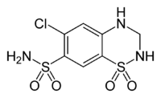
Well absorbed from the gastrointestinal tract. The diuretic effect develops after 30-60 minutes, reaches a maximum after two hours and lasts 6-10 hours. The drugs of this group reduce the active reabsorption of chlorine, respectively, the passive reabsorption of sodium and water in a wide part of the ascending part of the loop of Henle.
Receipt:
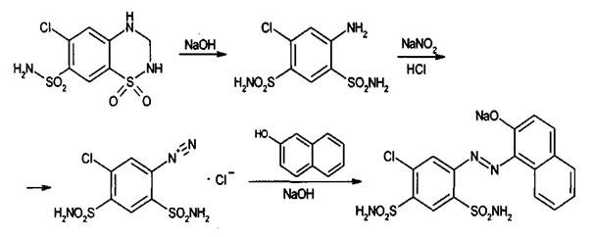
The mechanism of action of the drug is associated with a decrease in the energy supply of the process of chlorine transfer through the basement membrane. In addition, thiazide diuretics moderately inhibit the activity of carbonic anhydrase, which also increases natriuresis. Chloruresis under the action of this drug is carried out in an amount equivalent to natriuresis (that is, chloruresis also increases by 5-8%). When using the drug, there is a moderate loss of hydrocarbonate anion, magnesium, but an increase in blood plasma of calcium and uric acid ions.
Among all diuretics, thiazides have the most pronounced kaliuretic effect, as well as a decrease in the sodium content in the vascular wall, which reduces the vasoconstrictive reactions of biologically active substances. Dichlothiazide also potentiates the action of antihypertensive drugs used simultaneously with it. This drug reduces diuresis and thirst in diabetes insipidus, while reducing the increased osmotic pressure of blood plasma.
Advantages of thiazide diuretics:
• Sufficient activity of action;
• Act fast enough (after 1 hour);
• Act long enough (up to 10-12 hours);
• Do not cause pronounced changes in the acid-base state.
Disadvantages of thiazide diuretics:
• Since the drugs in this group act primarily in the distal tubules, they cause hypokalemia to a greater extent. For the same reason, hypomagnesemia develops, and magnesium ions are necessary for the entry of potassium into the cell.
• The use of thiazides leads to a retention of uric acid salts in the body, which can provoke arthralgia in a patient with gout.
• Drugs increase blood sugar levels, which in patients with diabetes mellitus can lead to an exacerbation of the disease.
• Dyspeptic disorders (nausea, vomiting, diarrhea, weakness).
• A rare but dangerous complication - the development of pancreatitis, lesions of the central nervous system.
Indications for use:
• Most widely used for chronic edema associated with chronic heart failure, liver cirrhosis, kidney disease (nephrotic syndrome).
• In the complex treatment of patients with hypertension.
• With glaucoma.
• In case of diabetes insipidus (the volume of circulating blood decreases, therefore, the feeling of thirst decreases).
• With idiopathic calciuria and oxalate stones.
• With edematous syndrome of newborns.
Polithiazide
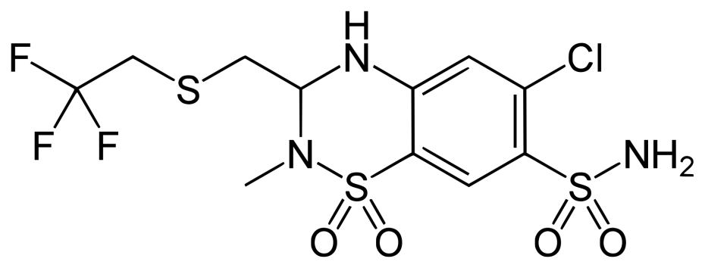
Cyclopenthiazide
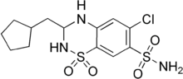

Receipt:
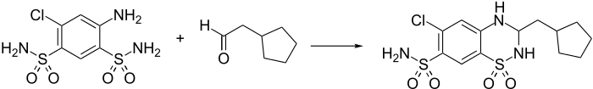
Cyclopenthiazide (trade name Navidrex) is a thiazide diuretic used to treat heart failure and hypertension.

Cyclothiazide
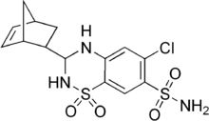

Receipt:
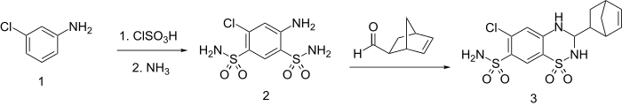
Cyclothiazide (anhydrone, aquirel, doburil, fluidil, renazide, tensodiural, valmiran), sometimes abbreviated as CTZ, is a benzothiadiazide (thiazide) diuretic and antihypertensive that was originally introduced in the United States in 1963 by Eli Lilly and subsequently also marketed in Europe. In 1993, it was discovered that cyclothiazide is a positive allosteric modulator of AMPA and kainate receptors, able to reduce or virtually eliminate the rapid desensitization of the first receptor and potentiate AMPA-mediated glutamate currents 18-fold at the highest levels. tested concentration (100 µM). In addition, in 2003, cyclothiazide was also found to act as a negative allosteric modulator of the GABA A receptor, potently inhibiting GABA A-mediated currents. In animals, it is a strong convulsant, strongly enhancing epileptiform activity and inducing seizures, but without overt neuronal death.
Cyclothiazide has been found to act as a non-competitive mGluR1 antagonist. It is selective for mGluR1 over other metabotropic glutamate receptors.
Epitizide
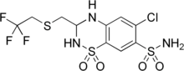
Epitizide is a diuretic. It is often combined with triamterene.
Meticlothiazide

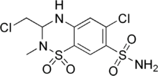
Trichlormethiazide
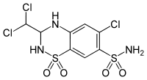
Receipt:
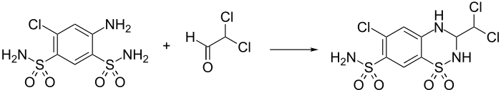
Trichlormethiazide (INN, currently sold under the brand names Akhletin, Diuhydrin, and Triflumen) is a diuretic with properties similar to those of hydrochlorothiazide. It is commonly prescribed for the treatment of edema (including those associated with heart failure, liver cirrhosis, and corticosteroid therapy) and hypertension. In veterinary medicine, trichlormethiazide can be combined with dexamethasone for use in horses with mild distal limb swelling and general bruising.
Trichlormethiazide appears to block active chloride and possibly sodium reabsorption in the ascending loop of Henle. This leads to the excretion of sodium, chlorides and water and thus acts as a diuretic. Although trichlormethiazide is used to treat hypertension, its hypotensive effect is not necessarily due to its role as a diuretic. Thiazides generally cause vasodilatation by activating calcium-activated potassium channels in vascular smooth muscle and inhibiting various carbonic anhydrases in vascular tissue.
As a diuretic (particularly a thiazide), trichlormethiazide promotes water loss from the body. Trichlormethiazide acts by inhibiting the reabsorption of Na + /Cl - ions from the distal tubules of the kidneys. In addition, trichloromethiazide increases the excretion of potassium.
Altizide
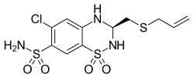
Altizide is a thiazide diuretic. In combination with spironolactone, it is sold under the brand names Aldactacine and Aldactazine by Pfizer and other companies.
Close in activity to thiazides, but superior to them in duration of action are the drugs CLOPAMIDE (BRINALDIX) and OXODOLIN (HYGROTON), as well as INDAPAMIDE and CHLORTHALIDONE.
Clopamid

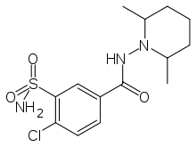
Clopamid (brand name Brinaldix) is a piperidine diuretic.
Clopamid is classified as a thiazide-like diuretic and acts similarly to thiazide diuretics. It acts in the kidney, in the distal convoluted tubule (DCT) of the nephron, where it inhibits the sodium chloride symporter. Clopamid binds selectively to the chloride binding site of the sodium chloride symporter in PCT cells on the luminal (inner) side and thus interferes with sodium chloride reabsorption, causing equiosmolar excretion of water along with sodium chloride.
Indapamide (Arifon)
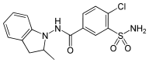
Indapamide is a drug with antihypertensive (diuretic, vasodilator) action. In terms of pharmacological properties, it is close to thiazide diuretics (impaired reabsorption of Na + in the cortical segment of the loop of Henle). It is used to treat hypertension and edema caused by heart failure.
Diuretic, vasodilating, hypotensive. Inhibits the reverse absorption of sodium ions in the cortical segment of the nephron loop, increases the urinary excretion of sodium, chlorine, calcium and magnesium ions. Reduces the sensitivity of the vascular wall to norepinephrine and angiotensin II; stimulates the synthesis of PGE2; inhibits the current of calcium ions in the smooth muscle cells of the vascular stack and, thus, reduces OPSS. Reduces production of free and stable oxygen radicals. Rapidly and completely absorbed when taken orally. Cmax is created after 2 hours. In plasma, 71-79% binds to proteins, and can also be sorbed by erythrocytes. Passes through histohematic barriers (including placental), penetrates into breast milk. T½ - about 14 hours. 70% is excreted by the kidneys and 23% - with faeces. Indapamide is excreted unchanged and as metabolites (7%). It has a dose-dependent effect. At a dose of 2.5 mg, it has the maximum hypotensive effect with a slight increase in diuresis.
Chlorthalidone (Oxodoline)
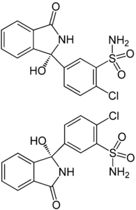
Chlorthalidone (oxodoline, hygroton) is a diuretic thiazide-like drug used both as a separate active substance and as part of combined drugs.
Suppresses the active reabsorption of Na +, mainly in the peripheral renal tubules (cortical segment of the loop of Henle), increasing the excretion of Na +, Cl - and water. The excretion of K+ and Mg2+ through the kidneys increases, while the excretion of Ca2+ decreases. It causes a slight decrease in blood pressure, the severity of the hypotensive effect gradually increases and manifests itself in full 2-4 weeks after the start of therapy. At the beginning of therapy causes a significant decrease in the volume of extracellular fluid, BCC and IOC; however, after several weeks of use, these indicators return to levels close to the original. Like thiazide diuretics, it causes a decrease in polyuria in patients with renal diabetes insipidus. The onset of action is 2-4 hours after ingestion, the maximum effect is 12 hours later, the duration of action is 2-3 days.
Indications: chronic heart failure II degree, arterial hypertension, cirrhosis of the liver with portal hypertension, nephrosis, nephritis, late preeclampsia (nephropathy, edema, eclampsia), fluid retention on the background of premenstrual syndrome, diabetes insipidus, dysproteinemic edema, obesity. With prolonged use, as well as with its simultaneous use with cardiac glycosides, glucocorticosteroids, ACTH, in order to prevent hypokalemia, it is recommended to prescribe potassium preparations (contraindicated when taking ACE inhibitors) or potassium-sparing diuretics (half dose of veroshpiron 12.5 instead of 25 with the simultaneous appointment of ACE inhibitors and chlorthalidone) .

III. Potassium-sparing diuretics
Aldosterone antagonists
Spironolactone (veroshpiron; Spironolactonum, Verospironum, "Gedeon Richter", Hungary; tab. 0.025 each)
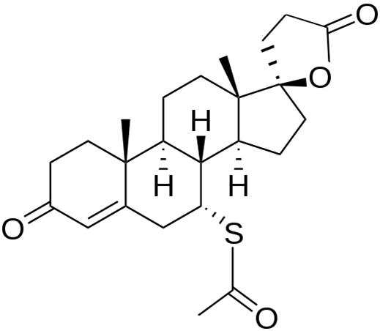
Weak potassium-sparing diuretic. Spironolactone is very similar in chemical structure to aldosterone (a steroid), and therefore blocks aldosterone receptors in the distal tubules of the nephron, which disrupts the reverse flow (reabsorption) of sodium into the cell of the renal epithelium and increases the excretion of sodium and water in the urine. This diuretic effect develops slowly - after 2-5 days and is rather weakly expressed. Inhibition of reabsorption of sodium filtered in the glomeruli is no more than 3%. At the same time, the inhibition of kaliuresis appears immediately after the administration of the drug. The activity of spironolactone is independent of the acid-base state. The drug has a significant duration of action (up to several days). It is a slow but long acting drug. The drug increases calciuresis, has a direct positive inotropic effect on the heart muscle.
Indications for use:
• Primary hyperaldosteronism (Kon's syndrome - a tumor of the adrenal glands). With this pathology, veroshpiron is used as a drug of conservative therapy.
• With secondary hyperaldosteronism, which develops in chronic heart failure, cirrhosis of the liver, nephropathic syndrome.
• In the complex therapy of patients with hypertension.
• Spironolactone is indicated for combination with other diuretics that cause hypokalemia, that is, for the correction of potassium balance, disturbed by the use of other diuretics (thiazides, diacarb).
• The drug is prescribed for gout and diabetes.
• Spironolactone is also prescribed to enhance the cardiotonic action of cardiac glycosides (the fact that spironolactone inhibits kaliuresis is also important here).
Side effects:
• Dyspeptic disorders (abdominal pain, diarrhea).
• With prolonged use in conjunction with potassium preparations - hyperkalemia.
• Drowsiness, headaches, skin rashes.
• Hormonal disorders (the drug has a steroid structure):
o men may experience gynecomastia;
o in women - virilization and menstrual irregularities.
• Thrombocytopenia.
Na-channel blockers
Triamterene, amiloride, according to the strength of action - weak diuretics.
Triamterene (pterophen).
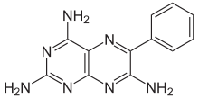
Available in capsules of 50 mg. Weak potassium-sparing diuretic, the onset of action after 2-4 hours, the duration of the effect is 7-16 hours. Violates sodium reabsorption in the collecting ducts and inhibits kaliuresis (distal). The drug enhances the action of other diuretics, especially thiazides, preventing the development of hypokalemia. Promotes the excretion of urates. It has a hypotensive effect of sufficient strength. The drug should not be prescribed to pregnant women, as there is an inhibition of reductase, an enzyme that converts folic acid to folinic acid. TRIAMPUR is a combination of triamterene and dichlothiazide.
Amiloride (tab. 5 mg).
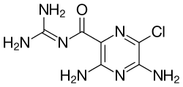

It is a potassium-sparing diuretic of weak strength, according to the average duration of action.
Amiloride, sold under the trade name Midamor among others, is a medication commonly used with other medications to treat high blood pressure or edema due to heart failure or cirrhosis of the liver. Amiloride is classified as a potassium-sparing diuretic. Amiloride is often used along with another diuretic such as a thiazide or loop diuretic. It is taken orally. The onset of action is about two hours and lasts about a day.
Common side effects include high blood potassium, vomiting, loss of appetite, rash, and headache. The risk of high blood potassium levels is higher in people with kidney problems, diabetes, and the elderly. Amiloride blocks the epithelial sodium channel (ENaC) in the late distal tubule, connecting tubule, and collecting duct of the nephron, which reduces the absorption of sodium ions from the lumen of the nephron and reduces the excretion of potassium ions into the lumen.
Amiloride, sold under the trade name Midamor among others, is a medicine commonly used with other medicines to treat high blood pressure or edema due to heart failure or cirrhosis of the liver. Amiloride is classified as a potassium-sparing diuretic. Amiloride is often used along with another diuretic such as a thiazide or loop diuretic. It is taken orally. The onset of action is about two hours and lasts about a day.
Common side effects include high blood potassium, vomiting, loss of appetite, rash, and headache. The risk of high blood potassium levels is higher in people with kidney problems, diabetes, and the elderly. Amiloride blocks the epithelial sodium channel (ENaC) in the late distal tubule, connecting tubule, and collecting duct of the nephron, which reduces the absorption of sodium ions from the lumen of the nephron and reduces the excretion of potassium ions. into the light.
IV. Carbonic anhydrase inhibitors
Acetazolamide (Diacarb) as a diuretic also belongs to weak diuretics.
Acetazolamide (Diacarbum (Diacarbum; phonurite, diamox; in powders and tablets of 0.25 or in ampoules of 125; 250; 500 mg)).
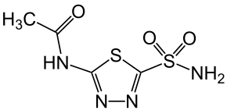
The drug is a diuretic of medium speed and duration of action (the effect occurs after 1-3 hours and lasts about 10 hours, with intravenous administration - after 30-60 minutes, for 3-4 hours). The drug inhibits the enzyme carbonic anhydrase, which normally contributes to the combination of carbon dioxide and water in nephrocytes with the formation of carbonic acid. The acid dissociates into a hydrogen proton and a bicarbonate anion, which enters the blood, and a hydrogen proton into the lumen of the tubules, exchanging for a reabsorbed sodium ion, which, together with the bicarbonate anion, replenishes the alkaline reserve of the blood.
A decrease in the activity of CAG with the use of diacarb occurs in the proximal parts of the nephron, which leads to a decrease in the formation of carbonic acid tubules in the cells. This leads to a decrease in the entry into the blood of the bicarbonate anion, which serves to replenish the alkaline reserve of the blood, and the entry into the urine of the hydrogen ion, which is exchanged for the sodium ion. As a result, the excretion of sodium in the urine in the form of bicarbonates increases; chlorine reabsorption changes little. The latter, combined with a decrease in the formation and entry into the blood of a hydrocarbonate anion, leads to the development of hyperchloremic acidosis. Compensatory increases in kaliuresis, which leads to hypokalemia. A decrease in the activity of CAG by diacarb in endothelial cells, cells of the choroid plexus, leads to a decrease in secretion and an improvement in the outflow of cerebrospinal fluid, which helps to reduce intracranial pressure. Diakarb lowers the production of intraocular fluid and reduces intraocular pressure, especially in patients with acute glaucoma. The exchange of sodium for potassium leads to the fact that this diuretic, being a relatively weak diuretic (inhibition of sodium reabsorption is not more than 3%), causes severe hypokalemia. In addition, due to the fact that sodium bicarbonate does not go back into the blood to replenish alkaline reserves, severe acidosis develops, and under conditions of acidosis, the action of diacarb stops. Thus, we can conclude that diacarb is rarely used as a diuretic.
Indications for use:
• In the treatment of patients with an acute attack of glaucoma (you can in/in).
• Traumatic brain injury with increased intracranial pressure.
• In some forms of small seizures of epilepsy.
• In combination with loop diuretics to prevent or eliminate metabolic alkalosis.
• In case of poisoning with salicylates or barbiturates to increase diuresis and alkalinity of urine.
• With a significant increase in the content of uric acid in the blood with the threat of its precipitation in leukemia, treatment with cytostatics.
• For the prevention of altitude sickness.
Diakarb is prescribed at 0.25 - 1 tablet per 1 dose per day daily for 3 - 4 days, followed by a break for 2-3 days, then such courses are repeated for 2-3 weeks.
All four of the above groups of agents primarily remove salts, primarily sodium and potassium, as well as anions of chlorine, bicarbonates, phosphates. That is why the drugs of these four groups are called saluretics.

V Osmotic diuretics
This group of diuretics includes mannitol, urea, concentrated glucose solutions, glycerin. Combine these drugs into one group of common mechanisms of action. The latter determine that the diuretic effect of these diuretics is strong, powerful.

Mannitol (Mannitol; Mannitolum)
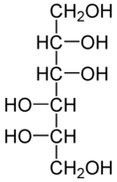
Hexatomic alcohol, which is the most powerful of the existing osmotic diuretics. It is able to increase diuresis by 20% of the total sodium filtered in the glomeruli.
Receipt:
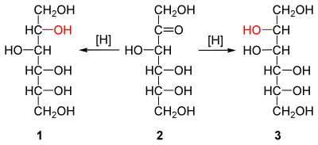
Produced in hermetically sealed bottles of 500 ml containing 30.0 of the drug, as well as in ampoules of 200, 400, 500 ml of a 15% solution. It comes out slowly. When administered intravenously, being in the blood, mannitol, like other diuretics of this group, sharply increases the osmotic pressure in the blood plasma, which leads to an influx of fluid from the tissues into the blood and an increase in BCC ("drying effect"). This leads to a decrease in the reabsorption of sodium and water in the distal part of the nephron, and also causes an increase in filtration in the glomeruli. In addition, mannitol is well filtered through the glomerular membrane and creates a high osmotic pressure in the urine, and is not reabsorbed in the tubules. Mannitol does not undergo biotransformation and is excreted unchanged, and therefore constantly attracts water and primarily removes it. The use of osmotic diuretics is not accompanied by hypokalemia and changes in the acid-base state. In terms of its ability to remove water from the body, mannitol is almost the most powerful drug.
Indications for use:
• Prevention or elimination of cerebral edema (shock, brain tumor, abscess) is the most common indication.
• Mannitol is indicated as a means of dehydration therapy for pulmonary edema that has arisen after the toxic effect of gasoline, turpentine, formalin on them; as well as edema of the larynx.
• When carrying out forced diuresis, in particular in case of poisoning with drugs (barbiturates, salicylates, sulfonamides, PAS, boric acid), with transfusion of incompatible blood.
• With an acute attack of glaucoma.
• To reduce damage to the kidney tubules during a sharp drop in filtration (in patients with shocks, burns, sepsis, peritonitis, osteomyelitis, in which the drug improves renal blood flow), in severe poisoning with hemolytic poisons (precipitation of proteins, hemoglobin - the risk of blockage of the renal tubules and development of anuria).
Side effects:
• headache
• nausea
• vomit
• sometimes allergic reactions.
These diuretics are placed in a separate group, since they primarily remove water from the body. The use of diuretics is designed to change the balance of sodium in the body, making it negative. Only in this case, increased sodium excretion will be accompanied by an increase in the excretion of water from the body and a decrease in edema.
Mercury preparations:
Mercuzal
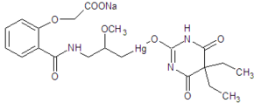
Mercuzal is a powerful diuretic. Not currently used due to general toxicity. Colorless or slightly colored transparent liquid of alkaline reaction.
Mercuzal is one of the most powerful diuretics. The increase in diuresis under the influence of Mercuzal mainly depends on its direct action on the kidneys. There are convincing experimental data in this regard. First, as Govarts has shown, transplanting a kidney from a dog previously treated with a drug like Mercusal into the neck of a normal dog that has not received it, the transplanted kidney continues to excrete an increased amount of urine, while transplanting a kidney from a normal dog into the neck of a dog that has been injected with the drug, the transplanted kidney does not give increased diuresis. Secondly, as shown by Bertram, when mercusal is injected into the renal artery, on the one hand, diuresis increases only in the corresponding kidney, while the other kidney does not give increased diuresis.
Increased diuresis under the action of Mercuzal occurs due to a decrease in reabsorption in the tubular apparatus of the kidneys. Experiments on a person with a creatine test fully confirm this principle in the action of mercusal.
Mercuzal binds sulfhydryl (SH) groups of enzyme systems of the kidneys, in particular succindehydrases, as a result of which the process of reabsorption in the tubules weakens. This is evidenced by the fact that dimercaptopurines, capable of splitting off SH-groups, sharply weaken the diuretic effect of mercusal. A decrease in tubular reabsorption leads to a significant increase in the release of chloride and sodium ions, which leads to an increase in diuresis.
The diuretic effect of Mercusal is to some extent dependent on extrarenal factors. So, by lowering the hydrophilicity of tissues, mercusal promotes the release of water from the body.
Promeran
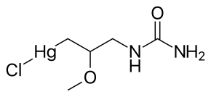
Mercuzal is a powerful diuretic. Not currently used due to general toxicity. Colorless or slightly colored transparent liquid of alkaline reaction.
Mercuzal is one of the most powerful diuretics. The increase in diuresis under the influence of Mercuzal mainly depends on its direct action on the kidneys. There are convincing experimental data in this regard. First, as Govarts has shown, transplanting a kidney from a dog previously treated with a drug like Mercusal into the neck of a normal dog that has not received it, the transplanted kidney continues to excrete an increased amount of urine, while transplanting a kidney from a normal dog into the neck of a dog that has been injected with the drug, the transplanted kidney does not give increased diuresis. Secondly, as shown by Bertram, when mercusal is injected into the renal artery, on the one hand, diuresis increases only in the corresponding kidney, while the other kidney does not give increased diuresis.
Increased diuresis under the action of Mercuzal occurs due to a decrease in reabsorption in the tubular apparatus of the kidneys. Experiments on a person with a creatine test fully confirm this principle in the action of mercusal.
Mercuzal binds sulfhydryl (SH) groups of enzyme systems of the kidneys, in particular succindehydrases, as a result of which the process of reabsorption in the tubules weakens. This is evidenced by the fact that dimercaptopurines, capable of splitting off SH-groups, sharply weaken the diuretic effect of mercusal. A decrease in tubular reabsorption leads to a significant increase in the release of chloride and sodium ions, which leads to an increase in diuresis.
The diuretic effect of Mercusal is to some extent dependent on extrarenal factors. So, by lowering the hydrophilicity of tissues, mercusal promotes the release of water from the body.
Promeran
Promeran is a powerful diuretic. Not currently used due to general toxicity. Colorless or slightly colored transparent liquid of alkaline reaction.
Promeran, like Mercusal, is a mercury diuretic and is similar to it in its mechanism of action. The diuretic effect of Promeran usually appears on the 2nd day of treatment and reaches a maximum on the 3rd-4th day. Promeran is used for circulatory failure with congestion, nephrosis and liver damage. It is prescribed orally in tablets containing 18 mg of the drug, 3-4 times a day after meals for 4-5 days. To enhance the action of promeran, ammonium chloride is prescribed simultaneously with it. In some cases, promeran causes side effects: dyspeptic disorders, skin itching.
Preparations of different groups
Magnesium citrate
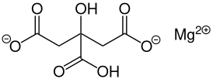
Maintains urine salts in a dissolved state and prevents their precipitation. Suppresses stone formation in the kidneys, even in small concentrations inhibits crystallization. Mg2+ ions bind up to 40% of oxalic acid in urine. Prevents precipitation of calcium compounds. It is an antidote for poisoning with salts of heavy metals.
Mozawaptan
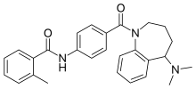
Mozavaptan (INN) is a vasopressin receptor antagonist marketed by Otsuka. In Japan, it was approved in October 2006 for the treatment of hyponatremia (low sodium in the blood) caused by inappropriate antidiuretic hormone syndrome (SIADH) due to ADH-producing tumors.
Tolvaptan
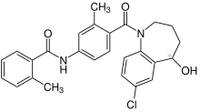
Tolvaptan, sold under the brand name Samsca among others, is an aquaretic that acts as a selective competitive vasopressin 2 (V 2 ) receptor antagonist used to treat hyponatremia (low blood sodium levels) associated with congestive heart failure, liver cirrhosis and syndrome of inappropriate antidiuretic hormone (SIADH).
Xipamide
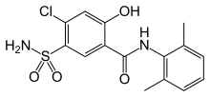
Xipamide is a sulfa diuretic marketed by Eli Lilly under the trade names Aquaphor (in Germany) and Aquaphoril (in Austria). It is used to treat edema and hypertension.
Like the structurally related thiazide diuretics, xipamide acts on the kidneys to decrease sodium reabsorption in the distal convoluted tubule. This increases luminal osmolarity, resulting in less water being reabsorbed by the collecting ducts. This leads to an increase in diuresis. Unlike thiazides, xipamide reaches its target from the peritubular side (blood side).
In addition, it increases the secretion of potassium in the distal tubules and collecting ducts. At high doses, it also inhibits the enzyme carbonic anhydrase, resulting in increased bicarbonate secretion and alkalinization of the urine.
Unlike thiazides, only terminal renal failure renders xipamide ineffective.
Combined drugs
Enalapril/hydrochlorothiazide
Triamterene/hydrochlorothiazide (Triampur)
Altisi/spironolactone

Medicinal substances used in violation of water-electrolyte (ion exchange) balance.
The total amount of water in the body, the content of electrolytes and the acid-base ratio are very tightly interconnected and are within well-defined boundaries. In different age periods, depending on the amount of adipose tissue, the human body consists of 55–70% water. Least hydrated adipose tissue. Therefore, the relative content of water in the body is less in women (55%), obese people, and also in senile people. Of the total amount of water in our body, 2/3 of the fluid is in the intracellular space, 1/3 is in the extracellular space. The extracellular fluid consists of intravascular (5% of body weight), interstitial (15% of body weight) and "third space" fluid - transcellular. This fluid is found in the serous cavities, glands, urinary system, cerebrospinal space, and intestines. Under physiological conditions, the "third space" is practically not taken into account, but in diseases it can reach a large volume. Normally, a person takes about 2–2.5 liters of liquid per day (1–1.5 liters of soups, drinks, etc. + 0.7 liters of other food + 0.3 liters of metabolically formed, that is, oxidative water ). An equivalent volume is excreted = 1–1.5 liters of urine + 0.5 liters through the skin + 0.4 liters through the lungs (with banal rhinitis it can increase up to a liter) + 0.4 liters with excrement. An increase in body temperature leads to a loss of water of 50-75 ml / day for every degree.
The ratio of electrolytes in the extra- and intracellular fluid is directly opposite, but the osmotic pressure is equal under normal conditions. Plasma osmolarity is determined by the level of sodium and clearly correlates with this value. Serum osmolarity (in mosm/l) can be calculated as: (serum sodium in mval/l +5)⋅2. In healthy people, the calculated os-molarity and real indicators are almost equal and amount to 285–295 mosm / l. If the difference is more than 10 mosm / l, then they speak of an osmolarity deficiency, which may be due to the use of alcohol, glucose or other osmotically active substances. The extra- and intracellular fluid are separated by cell membranes that are completely permeable to water. But the ion pump makes the membrane almost functionally impervious to water. When the osmotic pressure in the extracellular space changes, that is, when the sodium level changes, according to the laws of osmosis, water rushes towards a high sodium concentration until the osmotic pressure is equalized. The distribution of water between the intravascular bed and the intercellular space is regulated by hydrostatic and colloid osmotic pressure in the capillaries. The constancy of the osmotic pressure and volume of the liquid is regulated by a complex of mechanisms. Since the main cation of the extracellular space, which determines the volume, is sodium, the regulation of the extracellular volume is carried out by changing the excretion of sodium in response to its changing intake into the body. Fluctuations in extracellular fluid volume are accompanied by parallel changes in sodium excretion by the kidneys. For example, an increase in the volume of extracellular fluid immediately causes the excretion of sodium by the kidneys (natriuresis). Numerous receptors in the heart, blood vessels, kidneys ensure the coherence of this mechanism. Volume receptors are found in the atria, arteries, pulmonary veins, liver, and kidneys. They sense intravascular fluid volume (effective circulating blood volume) and regulate renal sodium excretion through the sympathetic nervous system, atrial natriuretic factor, the renin-angiotensin-aldosterone system, and intrarenal mechanisms.
Violations of the water-salt ratio can be classified as an extracellular fluid deficiency with a normal level of sodium in the blood serum, an increase in the volume of extracellular fluid with a normal level of sodium in the blood serum, hypo- and hypernatremia. A proportional change in sodium and water leads, respectively, to a deficit or excess of fluid in the extracellular space, which is known as exsicosis or overhydration. Violation of water-salt metabolism include:
Hyponatremia (below 135 mmol / l) indicates that the amount of water in the extracellular space in relation to sodium is increased.
Hypernatremia Detected when sodium concentration >145 mmol/L. Sodium concentration >160 mmol/l is critical.
Hypokalemia (<3.5 mmol/l)
Hyperkalemia (>5.5 mmol/l)
Hypocalcemia (<2.1 mmol/l)
Hypercalcemia
Hypermagnesemia (above 1.3 mmol/l)
Hypomagnesemia (below 0.8 mmol/l)
Hypophosphatemia (<1 mmol/l)
Hyperphosphatemia (>1.5 mmol/l)
Medicines used for treatment:
Potassium aspartate
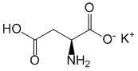
Sodium bicarbonate
NaHCO3
In the stomach, when taken orally, it interacts with hydrochloric acid of gastric juice and causes its neutralization. Reduces the acidity of gastric juice, relieves pain in gastric and duodenal ulcers. The antacid effect develops quickly, but is short-lived. The carbon dioxide formed in the neutralization reaction causes discomfort in the stomach (due to its distension) and belching, and also excites the receptors of the gastric mucosa, increases the release of gastrin with secondary activation of secretion. Excessive release of carbon dioxide in gastric ulcer can provoke perforation of its wall. For this reason, in case of poisoning with sodium acids, bicarbonate is not used for neutralization. Sodium and carbonic acid ions are included in the metabolic cycle. Having been absorbed into the blood, it shifts acid-base balance towards alkalosis, promotes the release of sodium and chlorine ions, increases osmotic diuresis, alkalizes urine (prevents precipitation of uric acid salts in the urinary system). It should be borne in mind that with vomiting accompanying peptic ulcer, chlorides are lost and alkalosis is aggravated by hypochloremia. It shifts the reaction of bronchial mucus to the alkaline side, promotes liquefaction of sputum, improves its expectoration. Relieves symptoms of sea and air sickness.
The shift of acid-base balance towards alkalosis during the usual short-term course of treatment is not accompanied by clinical symptoms, but in renal failure it can significantly worsen the condition. In patients with concomitant diseases of the heart or kidneys, excess intake of sodium causes edema and heart failure.
Hydroxyethyl starch
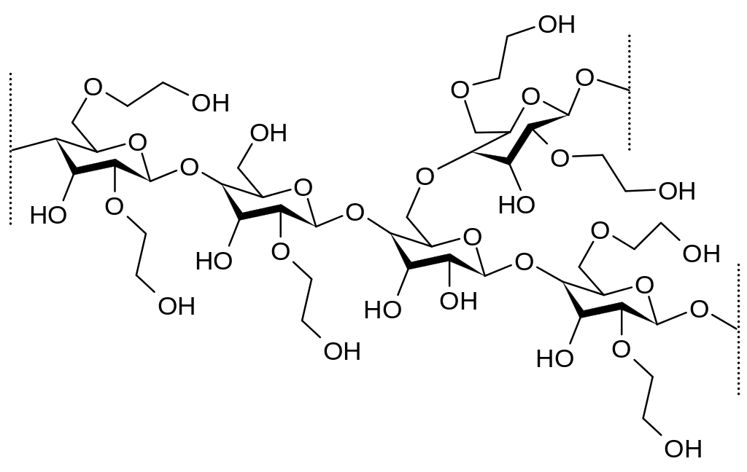
Preparations based on hydroxyethylated starch (HES) - a high-molecular compound consisting of polymerized dextrose residues. The source of HES production is natural starch (amylopectin), which undergoes cleavage to obtain molecules with a certain molecular weight, as well as hydroxyethylation, in which free hydroxyl groups of dextrose residues are replaced by hydroxyethyl groups at C2/C6 bonds. The latter contributes to a decrease in the rate of hydrolysis of amylopectin by serum amylase and an increase in the duration of its stay in the blood.
Gelatin
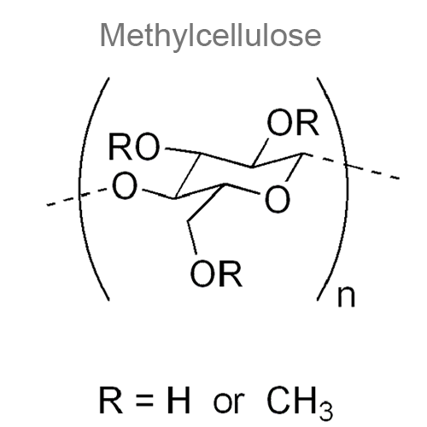
Due to the increase in circulating blood volume, it leads to an increase in venous return and cardiac output, normalization of blood pressure and perfusion of peripheral tissues. Causing osmotic diuresis, ensures the maintenance of kidney function during shock. Helps reduce blood viscosity, improves microcirculation. Due to its colloid-osmotic properties, it prevents or reduces the likelihood of developing interstitial edema. The volume-replacing effect is 100% and persists for about 5 hours after the administration of the drug.
Dimethyloxobutylphosphonyl dimethylate
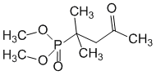
It exhibits antioxidant properties, dose-dependently reduces the intensity of lipid peroxidation, inhibits spontaneous and ADP-induced aggregation, increases the antioxidant potential of platelets and reduces the content of lipid peroxidation products in them. Normalizes the acid-base state by activating the metabolic mechanisms of its regulation (especially renal and pulmonary), enhancing intraorganic blood flow and tissue metabolism. It has a number of neuropharmacological effects: nootropic, antidepressant, decongestant and antiischemic, stress-protective, mnemotropic and antiamnesic. Improves cerebral circulation, normalizes the tone of cerebral vessels and blood supply to the brain, improves venous outflow. Neurotropic activity and cerebroprotective properties are due to the effect on the mechanisms of neurometabolic protection of the brain - it normalizes carbohydrate and energy metabolism, prevents the activation of lipid peroxidation, and increases the activity of antioxidant enzymes in the brain tissue. When applied topically, it has an antiseptic effect, increases the protective functions of the skin and mucous membranes.
Meglumine sodium succinate
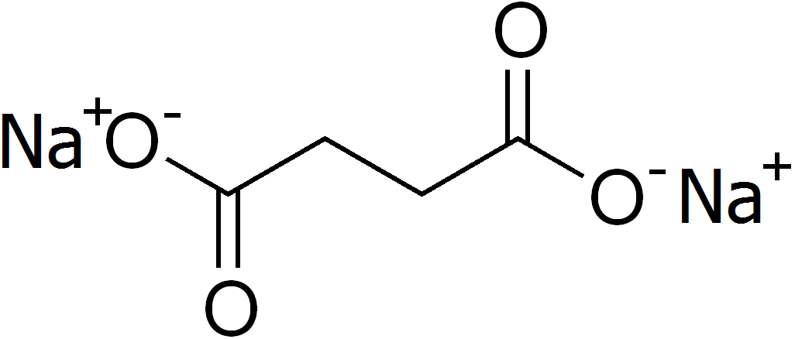
It has antihypoxic and antioxidant effects, having a positive effect on aerobic processes in the cell, reducing the production of free radicals and restoring the energy potential of cells. The drug activates the enzymatic processes of the Krebs cycle and promotes the utilization of fatty acids and glucose by cells, normalizes the acid-base balance and blood gas composition. It has a moderate diuretic effect.
Sodium acetate trihydrate
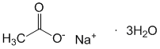
Sodium fumarate
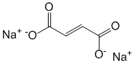
Sodium chloride
NaCl

Sodium citrate
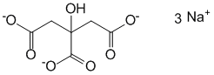
Ringer (Potassium chloride + Calcium chloride + Magnesium chloride + Sodium acetate + Sodium chloride (Kalii chloridum + Calcii chloridum + Magnii chloridum + Natrii acetas + Natrii chloridum).
Calcium polystyrenesulfonate
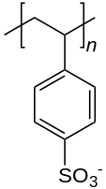
After oral administration to the gastrointestinal tract, calcium cations are released from the resin into the blood, being replaced by potassium cations from the patient's blood (mainly in the large intestine), which explains the therapeutic effect in hyperkalemia.
Trometamol
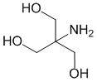
When administered intravenously, it reduces the concentration of hydrogen ions and increases the alkaline reserve of the blood, thereby eliminating acidemia, penetrates through the membranes into cells and helps to eliminate intracellular acidosis, is completely excreted by the kidneys unchanged and stimulates diuresis. When taken orally, it acts as a saline laxative.
Medicinal substances used in violation of acid-base balance.
A decisive factor in the constancy of all body functions is a stable level of hydrogen ions in body fluids. It is maintained by the ratio of acids (proton donators) and bases (proton acceptors). The level of hydrogen cations in arterial blood plasma is in the range of 37–43 nmol/l (37⋅10–6–43⋅10–6 meq/l). But in practical work, the concentration of hydrogen ions is expressed in terms of pH (the negative logarithm of the concentration of hydrogen cations).
Possible changes in pH are kept by the body within constant and very narrow limits by three mechanisms:
Buffer compounds are protein buffer, hemoglobin buffer, phosphate buffer, bicarbonate/pCO2 buffer.
Respiratory regulation of carbon dioxide release.
Renal regulation by changing the reabsorption of bicarbonate, the formation and release of titratable acids and ammonia.
The most important indicators in assessing the acid-base balance are:
blood pH (7.36–7.44);
serum bicarbonate level (22–27 mmol/l);
pCO2 of arterial blood (37–45 mm Hg).
The ratio of these three indicators is determined by the Henderson-Hasselbach formula: pH=6.1+log[HC03–(pC02⋅0.03)].
That is, when measuring pH and pCO2 of blood, it is always possible to calculate HCO3–.
But it follows from this that the pH is determined by the partial tension of carbon dioxide and the concentration of bicarbonate. In addition, to assess the acid-base state, in addition to determining pH, pCO2 and HCO3–, it is necessary to find out the concentration of anions, electrolytes (sodium, potassium, calcium, chlorides) in the blood serum, urine electrolytes (sodium, potassium, chlorine ) and its pH.
Violations of the acid-base balance may be due to a primary increase or decrease in pCO2 (respiratory acidosis or alkalosis, respectively) or a primary increase or decrease in the level of bicarbonates in the extracellular fluid (metabolic acidosis or alkalosis, respectively). Simple violations of acid-base balance are easily diagnosed by indicators of the gas composition of the blood.
Indicators of the gas composition of the blood in simple decompensated disorders of the acid-base state
Type of pH violation рСО2 НСО3–
Metabolic acidosis <7.36 <37+!
Respiratory acidosis <7.36+! +
Metabolic alkalosis >7.44 + +!
Respiratory alkalosis >7.44 <37 Reduced
+ - increase; ! - defining value.
Changes in pCO2 and HCO3 are friendly. So, in metabolic acidosis, the primary decrease in HCO3– is leveled by a decrease in pCO2 during hyperventilation. In metabolic alkalosis, the primary increase in HCO2 is correlated with a decrease in ventilation and an increase in pCO2.
Acidosis and alkalosis, once occurring, are fairly stable conditions. It takes about 6–11 hours to completely correct primary metabolic disorders, and 2–5 days to compensate for a primary respiratory disorder (SIC!).
Also known are the so-called mixed disorders of acid-base balance. They are due to the action of many factors leading to a shift in pH. Mixed respiratory-metabolic disorders, in contrast to the simple ones described above, occur with a simultaneous unilateral change in pCO2 and HCO3–. Therefore, they can be assessed only by special nomograms in conjunction with anamnestic and clinical information.
Main states:
Respiratory acidosis
Respiratory alkalosis
metabolic acidosis
metabolic alkalosis
Acesol
Compound:
Sodium acetate trihydrate - 2 g
Sodium chloride - 5 g
Potassium chloride - 1 g
The combined drug has a detoxifying, plasma-substituting, rehydrating, diuretic, anti-shock, antiplatelet effect. It has a hemodynamic effect, reducing hypovolemia, preventing blood clotting and the development of metabolic acidosis, improves capillary circulation, increases diuresis.
Disol
Compound:
Sodium acetate trihydrate
(in terms of sodium acetate) - 2 g
Sodium chloride - 6 g
Combined saline solution for rehydration and detoxification. Restores water and electrolyte balance and acid-base balance in the body during dehydration. Prevents the development of metabolic acidosis, increases diuresis. It has a plasma-substituting, detoxifying, rehydrating effect.
Ionoplasm
Potassium chloride + Magnesium chloride + Sodium acetate + Sodium gluconate + Sodium chloride
Ionosteril
Potassium acetate + Calcium acetate + Magnesium acetate + Sodium acetate + Sodium chloride
potassiumdex
Compound:
Potassium chloride
Glucose monohydrate
(dextrose monohydrate)
Indications: Treatment and prevention of hypokalemia of various origins (including arrhythmias caused by hypokalemia).
Kaliyanat
Potassium chloride + [Sodium chloride]
Quintasol
Compound:
1 liter of solution contains:
Sodium chloride - 5.26 g,
Potassium chloride - 0.37 g,
Calcium chloride (in terms of anhydrous substance) - 0.28 g,
Magnesium chloride 6 water (in terms of anhydrous substance),
Sodium acetate 3 aqueous (sodium acetate trihydrate)
(in terms of anhydrous substance) - 0.14 g,) - 4.10 g,
Indications:
– Shock (complex treatment), thermal injury, acute blood loss; hypohydration (isotonic and hypotonic forms);
– Metabolic acidosis (including acute intestinal infections with dehydration);
– Acute diffuse peritonitis;
– Intestinal obstruction (for correction of water and salt balance); electrolyte disturbances in patients with intestinal fistulas; therapeutic plasmapheresis (dialysis-filtration method).
Methusol
Potassium chloride + Magnesium chloride + Sodium chloride + Sodium fumarate
Combined drug; It has a rehydrating, antiplatelet, antioxidant, diuretic and detoxifying effect. Activates cell adaptation to lack of oxygen; quickly replenishes the volume of circulating blood in hypovolemic conditions, prevents tissue dehydration, reduces blood viscosity, improves its rheological properties, and exhibits a hemodynamic effect.
Neohemodes
Potassium chloride + Calcium chloride + Magnesium chloride + Sodium bicarbonate + Sodium chloride + Povidone-8 thousand.
Normacor
The combination of potassium chloride + magnesium sulfate + mannitol prolongs the resistance of the myocardium to hypoxia by blocking the launch of energy-consuming processes, reducing the energy needs of the myocardium to a minimum level. Provides effective protection of the myocardium from ischemic and reperfusion injuries under conditions of normothermia or moderate hypothermia and does not limit the duration of operations.
Hartmann's solution
Potassium chloride + Calcium chloride + Sodium chloride + Sodium lactate
Increases plasma volume, replenishes electrolyte deficiency.
Regidron
Dextrose + Potassium chloride + Sodium chloride + Sodium citrate
Sorbilak
Раствор для инфузий | 1 мл
активные вещества:
сорбитол | 200 мг
натрия лактат | 19 мг
натрия хлорид | 6 мг
кальция хлорид (в пересчете на сухое вещество) | 0,1 мг
калия хлорид | 0,3 мг
магния хлорид (в пересчете на сухое вещество) | 0,2 мг

The main pharmacologically active substances are sorbitol (in hypertonic concentration) and sodium lactate (in isotonic concentration). In the liver, sorbitol is first converted to fructose, which is then converted to glucose and then to glycogen. Part of the sorbitol is used for urgent energy needs, the other part is stored as a reserve in the form of glycogen.
Hypertonic solution of sorbitol has a high osmotic pressure and a pronounced ability to increase diuresis.
Trisol
Sodium chloride - 5 g, potassium chloride - 1 g, sodium bicarbonate - 4 g.
A plasma-substituting agent that reduces hypovolemia, increases diuresis, reduces blood clotting and metabolic acidosis, improves capillary circulation, and has a detoxifying effect.

